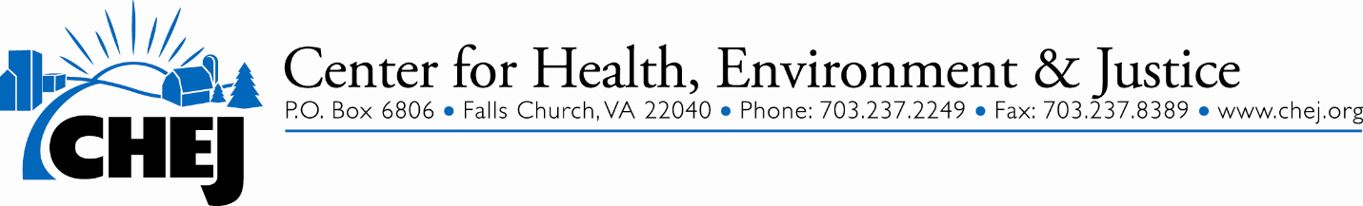
March 3, 2016

Subject line on email – CHEJ Small Grants Available

Dear Friend,

CHEJ has a Small Grants Program for local grassroots groups working on environmental health and justice issues. We would greatly appreciate your help in sending this announcement to grassroots groups in your network. If you are a grassroots group, please consider submitting an application.

Grassroots communities of color, low wealth, faith based, rural and urban groups are encouraged to apply. This grant program will support projects that help groups move towards their goals by building leadership and/or the group’s capacity. These projects could include meetings to develop an organizing strategy plan, training events, educational activities or membership outreach. The grant awards will be up to $2,000 per group with annual budgets of no more than $50,000. Attached is the CHEJ Small Grants Application Form.

If you are a grassroots group, but are not incorporated and do not have a bank account, you will need to find a group that can accept the funds for your group, such as a church or other non-profit who will serve as a “fiscal sponsor “ to accept the funds.

The deadline for submitting the application is Friday April 8, 2016. Applications should be submitted to CHEJ at info@chej.org. Please check our application form carefully for more specifics on our guidelines. If you have questions, feel free to give us a call.

Thank you.

Lois Marie Gibbs
CHEJ Leadership Training Academy

Mentoring a Movement, Empowering People, Preventing Harm
O 703-237-2249, F 703-237-8389
www.CHEJ.ORG
CHEJ's blog! www.chej.org/blog
CHEJ on Twitter: twitter.com/chej
CHEJ on Facebook: www.facebook.com/CHEJfans
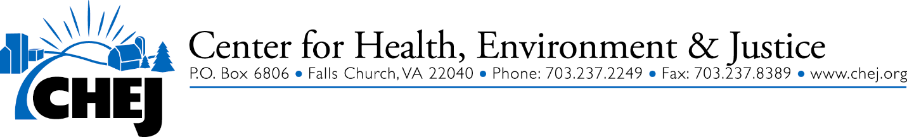
CHEJ Small Grants Application Form
Application Deadline: April 8, 2016

CHEJ’s Small Grants Program helps grassroots, community organizing groups build their capacity. The program is designed to especially reach people from low wealth communities and communities of color who are impacted by environmental harms. Grant activities can include board development, membership outreach, and fundraising efforts. Project activities could also include meetings to develop an organizing strategic plan, training events, educational activities which are directly connected to your strategic plan, or membership recruitment. It is recommended that project activities be creative, effective and/or strategic.

This grant program is looking to fund small grassroots community-based organizations (with budgets of no more than $50,000) that are working on environment, health and justice issues. The proposed project must be completed and a final report submitted by December 1, 2016. The grant application should be no longer than 3 pages plus the budget page. There is no word limit in each section/question of the application. Additional attachments are acceptable. Grant awards will be up to $2,000 per group.

Although we believe that many efforts in the field are valuable in creating change, our funds are limited. Projects such as film production, community gardens, legal assistance, market campaigns, and food banks are not likely to be supported. CHEJ’s program is focused on addressing environmental and associated public health harms.

Please answer the following questions and submit the application to CHEJ at Info@chej.org by April 8, 2016.

Your Name: ____________________________________________________________

Group Name:___________________________________________________________

Email Address: _________________________________________________________

Mailing Address: (Street, City, Zip code):_____________________________________

Phone Number: _________________________________________________________

1) What issue(s) is your group working on? How long has your group been working on these issues?

2) What are your group’s overall goals? Has your group had any achievements? If so, please briefly describe.

3) Organizational Information

- Is your group led by people from the impacted community? Yes ___ No ____

- Are your core leaders all volunteer or do you have paid staff?

We are all volunteers ______. We have volunteers and ___ # paid staff

- Does your leadership include low wealth community people and/or people of color?

% of Low wealth leaders _____ % of Leaders of color ______

- How many people are on your mailing list ____; come to your regular meetings ___ ;
come to your large events/ ____

4) Please describe your group’s proposed project including its main objective(s).

Project goal(s):

How will you accomplish this goal(s)?

5.) If your group is not incorporated and does not have a bank account, you will need to find a group that can accept the funds for your group, such as a church or other non-profit who will serve as a “fiscal sponsor” to accept the funds. If your group is not incorporated, please provide the name and contact information of the fiscal sponsor for your group.

Fiscal sponsor:

6) Budget Questions: Please provide your annual organizational budget and a specific budget that shows the expenses for the proposed project. List other funds committed to the project, if applicable. Items that are needed for the project and costs should be listed in the columns below. Don’t worry if you have never put together a budget. Do the best you can by listing the items and the costs for each line item.

Organizational Budget | CHEJ’s Grant Project Budget
For example:
Printing poster 300.00
 | Meeting Facility 100.00

7) What amount are you requesting? ($2,000 is the maximum grant award)

Please send this application form to CHEJ at info@chej.org by May 8, 2016

If you have questions about the grant application form or the grant process, please contact us at info@chej.org

